User Guide

Building from CMD –

Necessary Dependencies:

* Python 3 (https://www.python.org/downloads/)
* PyODBC (pip install pyodbc)
* Pandas (pip install pandas)
* PandasGUI (pip install pandasgui)
* BeautifulSoup (pip install beautifulsoup)
* Tkinter (pip install tkinter)
* PIL (pip install pillow)
* Time (pip install time)
* Numpy (pip install numpy)

Login Window:

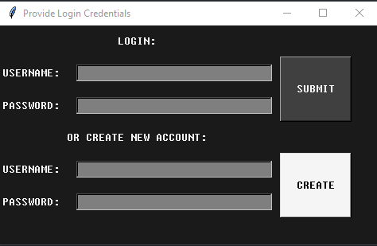

When accessing the User Screen, you have 3 options:

1. Login with an existing account
2. Create a new account
3. Select the (x) and the program will load a guest user profile

Root Display:

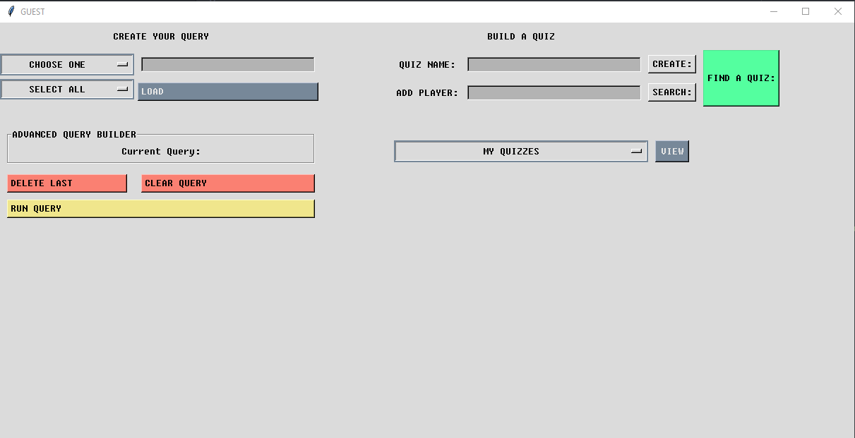

When accessing the Root Display, you have 3 major Options:

1. Create Your Query
2. Build a Quiz
3. Find A Quiz

Create Your Query:

This powerful tool allows users to search a database of all current NBA players based on a massive set of filters. First, you can select a filter like “Age” and set an option, you can then leave the second option as “Select All” to see all known statistics for every player that age or limit it further by choosing an additional option. Once your query options are prepared you will select the “Load” option to prep the query and then select “Run Query”. (We are currently getting a QTWebEngineProcess error when loading queries with PandasGUI, but it still loads properly). Here is an example query for 26-year-old players sorted by Points per game.

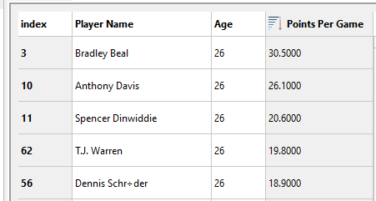

Build a Quiz:  
 Build a Quiz allows a user to create a quiz of players and add hints to solving the players identity. When creating a quiz you will need to pick a name for it, and then press “Create:”. After pressing create you will be given the option of adding a description to the quiz to help narrow down search options. Once you have determined your description press “Submit” and then exit out of the window.

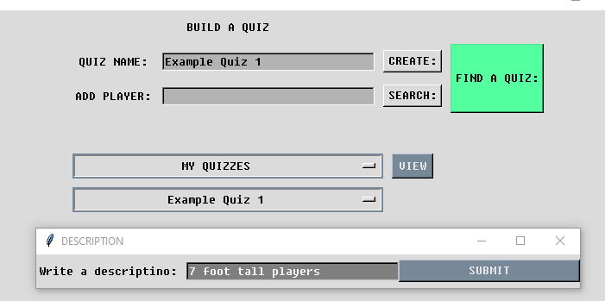Now you will be able to search for a player to add to your quiz, if you do not know who you want to add you can run a query for the description to find players that meet your criteria.

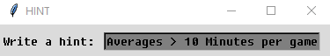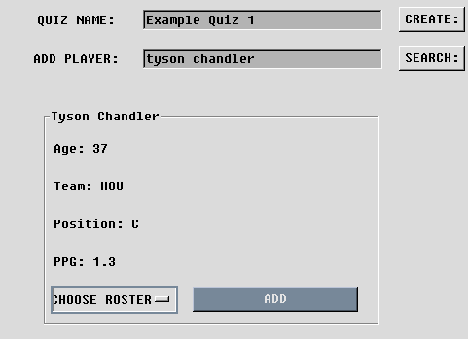Below you can see where I searched for Tyson Chandler, a 7’1 player for the Houston Rockets. After clicking search an information box appears with a dropdown menu allowing you to select a roster to add him too. If you are signed in with an account, you can add to any of the quizzes you currently have made. Once you are ready you can hit “Add” and a hint box will appear. This hint is meant to assist the contestant in finding the player you are referencing. For Tyson we will say “Averages > 10 minutes per game, and is 37 years old”

Find a quiz:

The find a quiz option allows the user to locate available quizzes and take them. These quizzes are listed in a separate window and list the Author, the Quiz Name and the Quiz Description

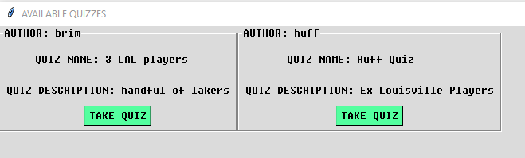

Once you find a quiz you would like to take you can select “Take Quiz” and it will open the quiz in a separate window with entry options and the hint beside it. Once you feel confident you can press “Submit” and the box will light up green if the answer is correct or red if incorrect. When answering questions if you are unsure of spelling you can utilize the query search in the root window to assist you in finding players. (answers are case-sensitive)

Before:

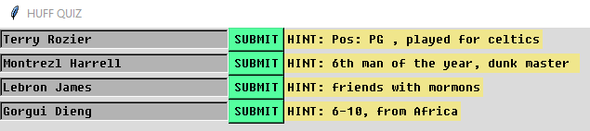

After:

